Request for payment

INV DATE : 6/15/2023

TO,
PSG Public School, Coimbatore

S.NO | DESCRIPTION – Contribution towards Concert of | Date of event | TOTAL AMOUNT
4 | Rendezvous Series Mohiniattam concert of Smt Anupama Menon | 15th June 2023 | Rs 6000

Total (in Rupees): Rs 6000

Amount in words: Rupees Six Thousand Only

Cheque/NEFT may please be made in favour of “SPIC MACAY”

The bank account details are as follows:

Kindly arrange the payment by NEFT/Bank transfer to our

Current Account :- Bank State Bank of India ( Modern School, Barakhamba Road )

State New Delhi

A/c Name SPIC MACAY

A/c No 10773571902

IFSC SBIN0011781

PAN AABTS8382A T

AN DELS27706A Registered office: 41/42 Lucknow Road, New Delhi – 110054.

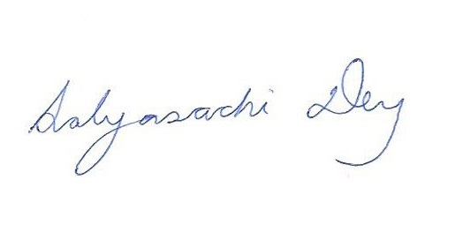
(Sabyasachi Dey)
National Coordinator,
SPIC MACAY

